**Name: Muhammad Ali Shafqiue**

**Market Trends Analysis Report(Week 13)**

1. **Introduction**

This report presents an analysis of market trends using a dataset containing product price information across different categories. The primary goal was to extract key insights regarding consumer behavior, product trends, and market demands.

1. ****Methodology****

The analysis was performed using Python in Google Colab, leveraging libraries such as Pandas, NumPy, Matplotlib, and Seaborn. The dataset was cleaned, visualized, and key findings were extracted to understand pricing trends in different product categories.

1. **Data Collection**

The dataset contains information on various products, including smartphones, laptops, and tablets, along with their respective prices. The data was structured in a CSV format and loaded into Python for further processing.

**4. Data Cleaning & Preparation**

* Ensured all prices were in numeric format.
* Handled missing values by removing any null entries.
* Categorized products into relevant groups for easier analysis.

****5. Data Analysis & Insights****

**Price Distribution:** A histogram was plotted to visualize how product prices are distributed.

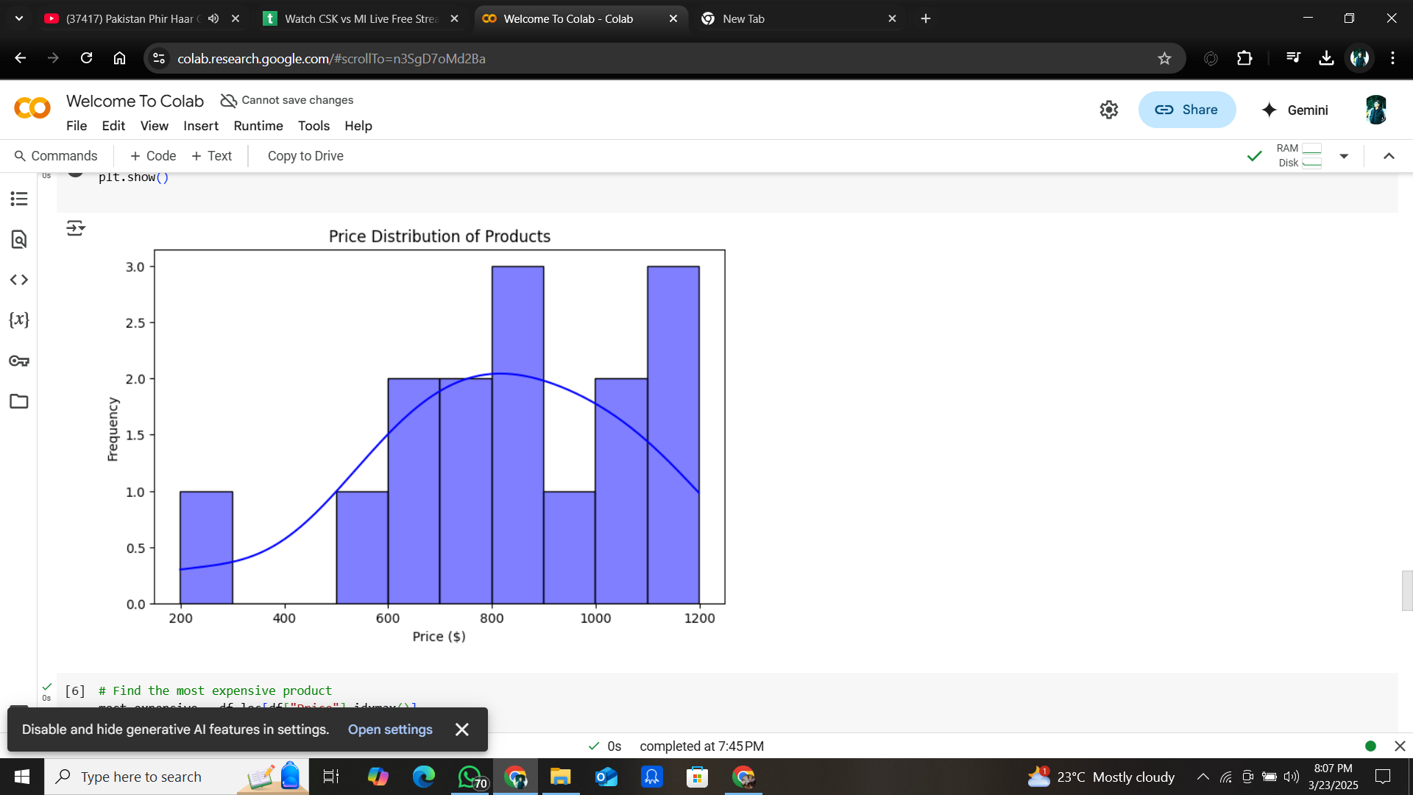

**Most Expensive & Cheapest Products:**

The most and least expensive products were identified.

****Category-wise Average Price:****

A bar chart was generated to compare average prices across different categories.

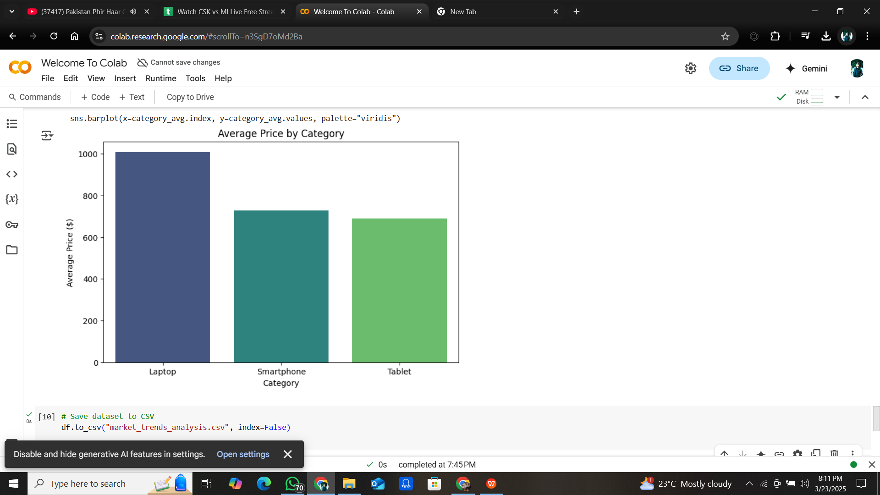

**6. Findings**

* The most expensive product in the dataset was identified as the MacBook Air ($1199), while the cheapest was Amazon Fire HD ($199).
* Laptops had the highest average price compared to smartphones and tablets.
* The price distribution showed a significant concentration of products within the mid-range price segment.

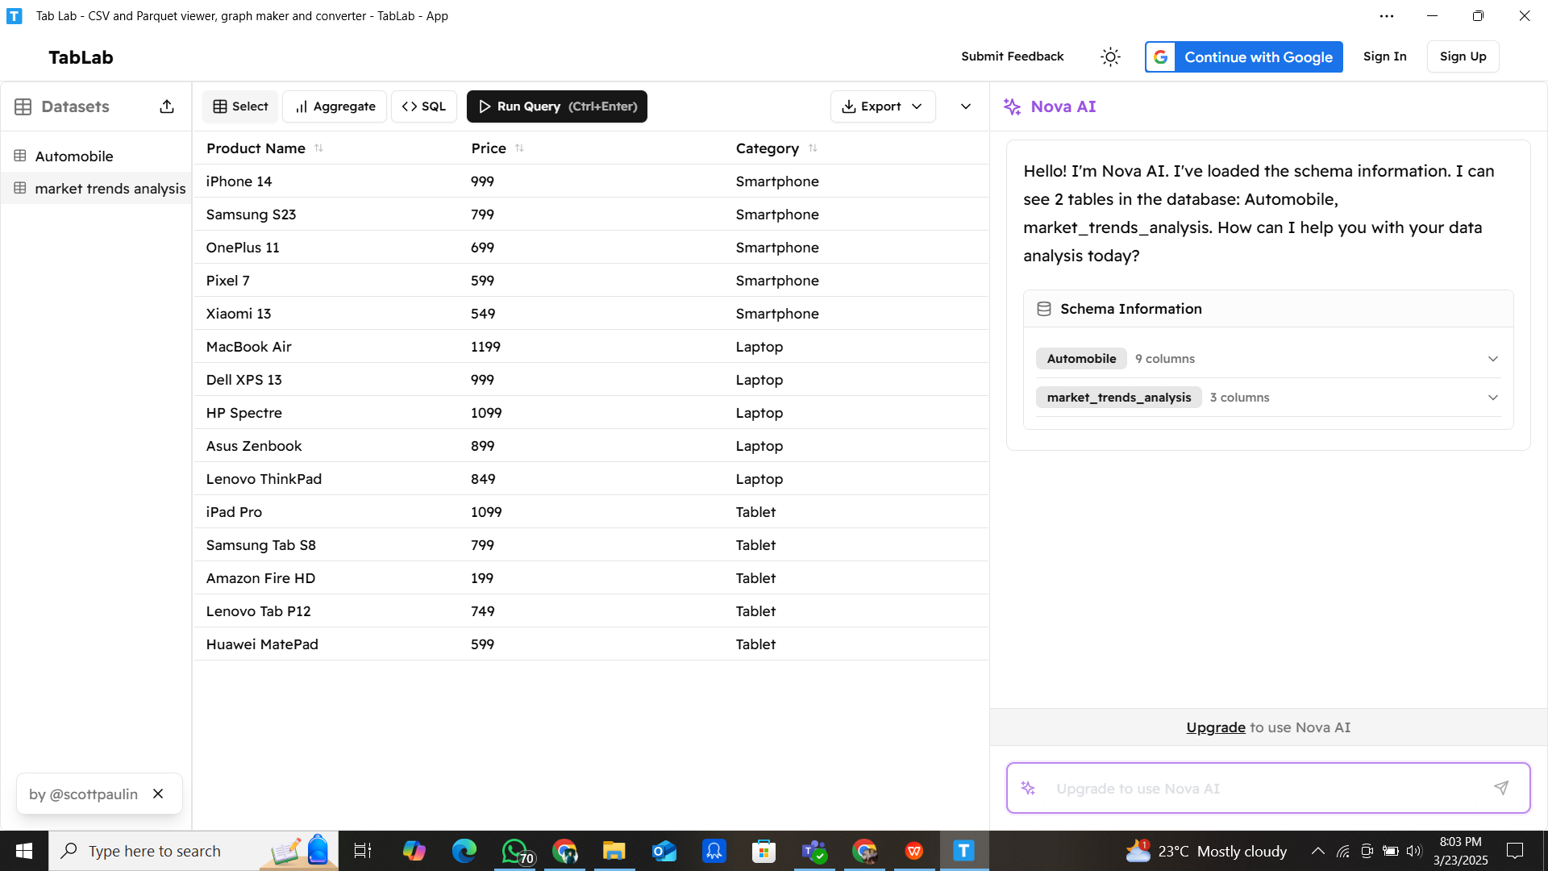

1. **Conclusion**

This analysis provides valuable insights into market trends and pricing structures. Understanding these trends can help businesses make data-driven decisions regarding pricing strategies and consumer demand.

**8. Next Steps**

* Further expand the dataset with real-world pricing data.
* Include additional product features like brand, specifications, and user ratings.
* Automate data collection using web scraping techniques.

**9.GitHub Upload**

The processed dataset has been saved and can be uploaded to GitHub for further use and sharing.